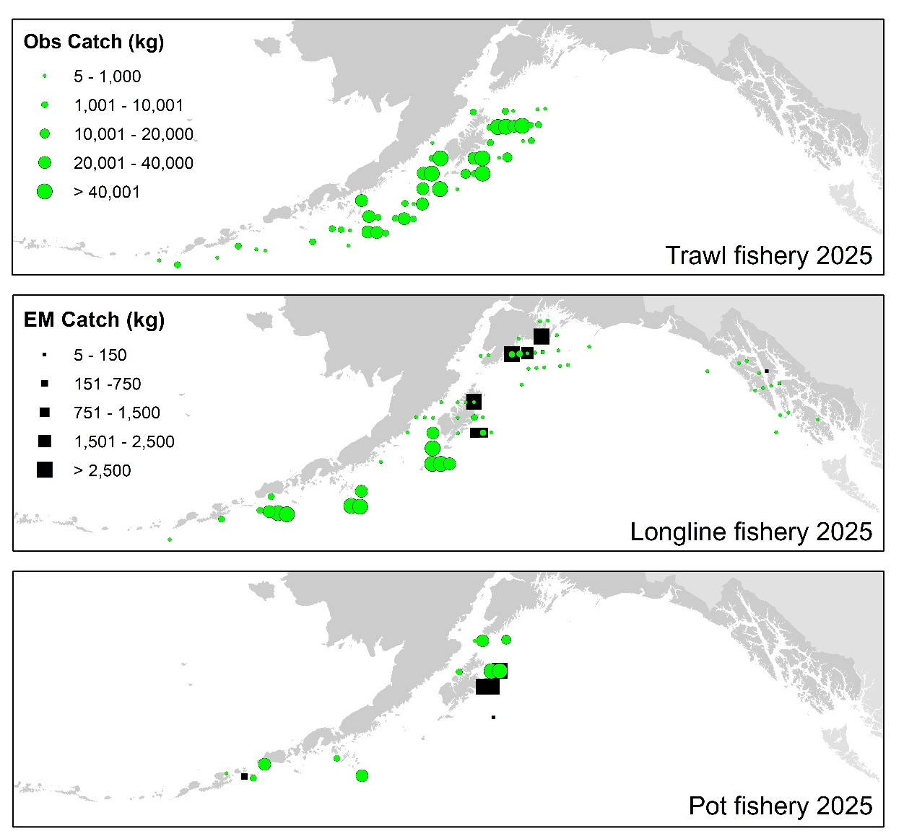

Figure 2.5. Observed (Obs) and electronic monitored (EM) commercial catch of Pacific cod in the GOA by 20 km² grid for 2025. These summed data include bycatch Pacific cod, but do not include trawl EM data as locations are not yet available.

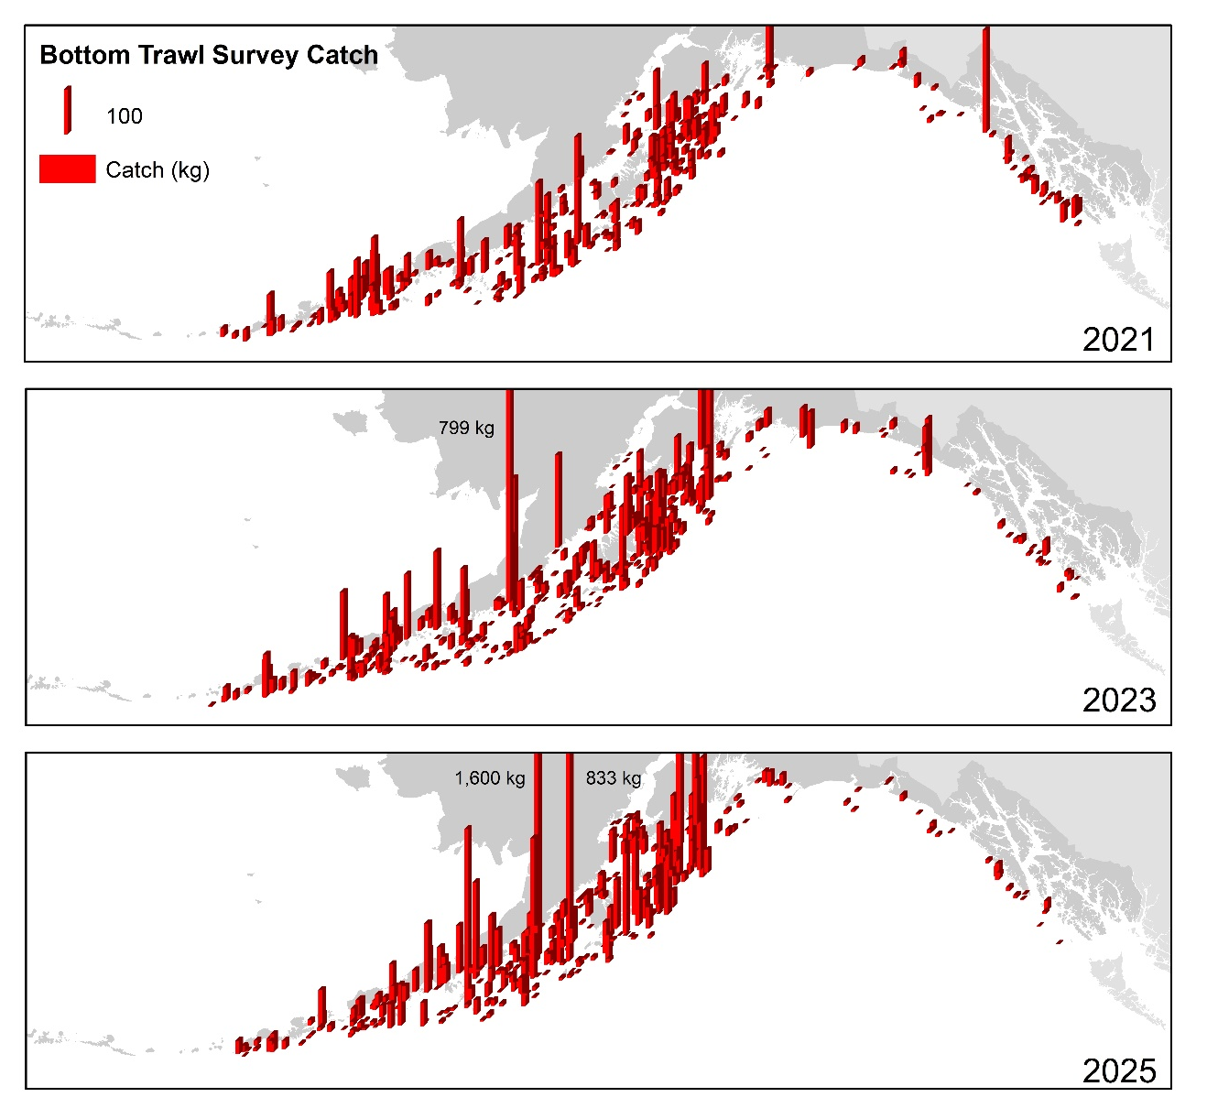

Figure 2.11. Distribution of AFSC bottom trawl survey catch (kg) of Pacific cod for 2021-2025.

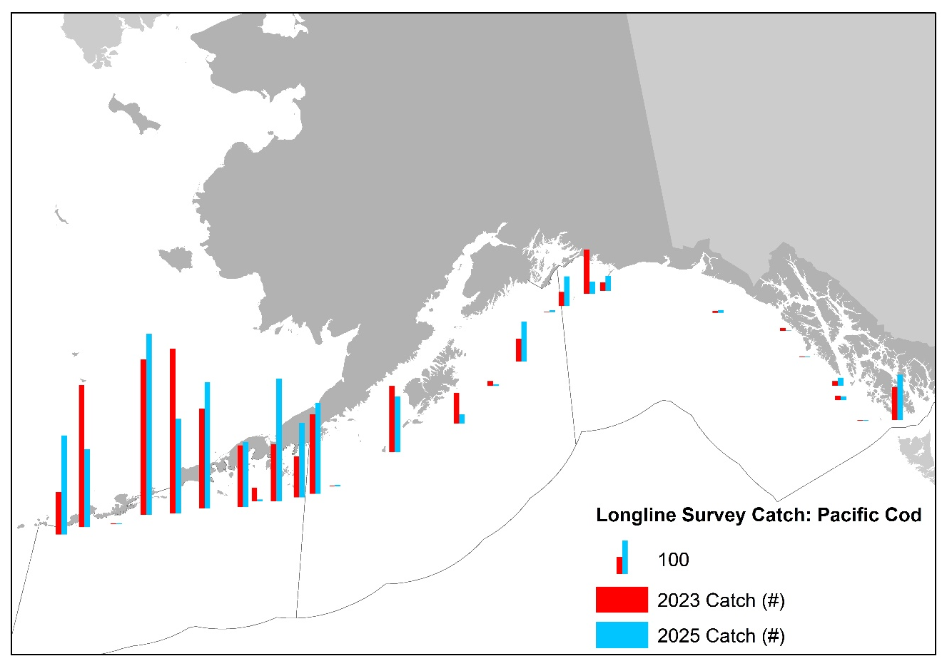

Figure 2.12. Distribution of AFSC longline survey catch (numbers) of Pacific cod in 2023 and 2025. Note there was no longline survey in 2024.

